CISSP® Domains

The CISSP domains are drawn from various information security topics within the (ISC)² CBK. The CISSP CBK consists of the following 8 domains:

**Security and Risk Management (Security, Risk, Compliance, Law, Regulations, and Business Continuity)**

* + - Confidentiality, integrity, and availability concepts
    - Security governance principles
    - Compliance
    - Legal and regulatory issues
    - Professional ethic
    - Security policies, standards, procedures and guidelines

Asset Security (Protecting Security of Assets)

* + Information and asset classification
  + Ownership (e.g. data owners, system owners)
  + Protect privacy
  + Appropriate retention
  + Data security controls
  + Handling requirements (e.g. markings, labels, storage)

**Security Engineering (Engineering and Management of Security)**

* + - Engineering processes using secure design principles
    - Security models fundamental concepts
    - Security evaluation models
    - Security capabilities of information systems
    - Security architectures, designs, and solution elements vulnerabilities
    - Web-based systems vulnerabilities
    - Mobile systems vulnerabilities
    - Embedded devices and cyber-physical systems vulnerabilities
    - Cryptography
    - Site and facility design secure principles
    - Physical security

Communication and Network Security (Designing and Protecting Network Security)

* + - Secure network architecture design (e.g. IP & non-IP protocols, segmentation)
    - Secure network components
    - Secure communication channels
    - Network attacks

**Identity and Access Management** (Controlling Access and Managing Identity)

* + - Physical and logical assets control
    - Identification and authentication of people and devices
    - Identity as a service (e.g. cloud identity)
    - Third-party identity services(e.g. on-premise)
    - Access control attacks
    - Identity and access provisioning lifecycle (e.g. provisioning review)

**Security Assessment and Testing (Designing, Performing, and Analyzing Security Testing)**

* + - Assessment and test strategies
    - Security process data (e.g. management and operational controls)
    - Security control testing
    - Test outputs (e.g. automated, manual)
    - Security architectures vulnerabilities

**Security Operations** (Foundational Concepts, Investigations, Incident Management, and Disaster Recovery)

* + - Investigations support and requirements
    - Logging and monitoring activities
    - Provisioning of resources
    - Foundational security operations concepts
    - Resource protection techniques
    - Incident management
    - Preventative measures
    - Patch and vulnerability management
    - Change management processes
    - Recovery strategies
    - Disaster recovery processes and plans
    - Business continuity planning and exercises
    - Physical security
    - Personnel safety concerns

**Software Development Security (Understanding, Applying, and Enforcing Software Security)**

* + - Security in the software development lifecycle
    - Development environment security controls
    - Software security effectiveness
    - Acquired software security impact

**CISSP FLASH CARDS**

**Software Development Security Domain**

Waterfall Development Model: A development model in which each phase contains a list of activities that must be performed and documented before the next phase begins.

**Communications and Network Security Domain**

Wireless metropolitan area networks: A type of wireless network that connects several wireless LANs.

Concentrators: Multiplex connected devices into one signal to be transmitted on a network.

Direct-Sequence Spread Spectrum (DSSS): A wireless technology that spreads a transmission over a much larger frequency band, and with corresponding smaller amplitude.

Bastions hosts: Server as a gateway between trusted and untrusted network that gives limited, authorized access to untrusted hosts.

Decryption: The process of transforming encrypted data back into its original form, so it can be understood.

Fiber Channel over Ethernet (FCoE): A lightweight encapsulation protocol and lacks the reliable data transport of the TCP layer.

Firewalls: Devices that enforce administrative security polices by filtering incoming trafficked base on a set of rules.

Modems: Allow users remote access to a network via analog phone lines.

OSI reference model: Layering model structure into seven layers (Physical layer, data-link layer, network layer, transport layer, sesson layer, presentation layer, application layer)

Lightweight Directory Access Protocol (LDAP): A client/server-based directory query protocol loosely based upon X.500, commonly used for managing user information.

Wireless mesh network: A wireless network made up of radio nodes organized in a mesh topology

Traceroute: A diagnostic tool that displays the path a packet traverse between a source and destination host

Common application service element (CASE): Sublayer that providers service for the application layer and request service from the session layer.

Ping scanning: A basic network mapping technique that helps narrow the scope of an attack.

Public-Key encryption: Involves a pair of keys-a public key and private key-associated with an entity that needs to authenticate its identity electronically or to sign or encrypt data.

Spread spectrum: A method commonly used to modulate information into manageable bits that are sent over the air wirelessly.

TCP/IP or Department of Defense(DoD) model: Layering model structure into four layers (link layer, network layer, transport layer, application layer)

### Transmission Control Protocol (TCP): Provides connection-oriented data management and reliable data transfer. (TCP 3-Way Handshake (1) SYN (2) SYN-ACK (3) ACK

### http://www.tcpipguide.com/free/diagrams/tcpopen3way.png

User Datagram Protocol (UDP): Provide a lightweight service for connectionless data transfer without error detection and correction.

Bridges: Layer 2 device that filter traffic between segments based on Media Access Control (MAC) addresses.

Frequency-Hopping Spread Spectrum (FHSS): This wireless technology spreads its signal over rapidly changing frequencies.

Internet Control Message Protocol (ICMP): Provides a means to send error messages for non-transient error condition and provides a way to probe the network in order to determine general characteristics about the network.

Physical Layer: Layer 1

Data-Link Layer: Layer 2

Network Layer: Layer 4

Virtual Private Network(VPN): An encrypted tunnel between two hosts that allows them to securely communicate over an untrusted network.

Voice over Internet Protocol (VoIP): A technology that allows you to make voice calls using a broadband internet connection instead of a regular (or analog) phone line.

Wireless local area network (WLAN): Links two or more devices over a short distance using a wireless distribution method, usually providing a connection through an access point for internet access.

Vi

**Security and Risk Management Domain.**

Physical Controls: Controls to protect the organization’s people and physical environment, such as locks, file management, gates, and guards; physical controls may be call “OPERATIONAL CONTROLS” in some contexts.

Recovery Controls: Controls implemented to restore condition to normal after a security incident.

Preventive Controls: Controls implemented to prevent a security incident or information breach.

Deterrent Controls: Controls designed to discourage people from violating security directives

Detective Controls: Controls designed to signal a warning when a security control has been breached.

Corrective Controls: Controls implemented to remedy circumstance, mitigate damage, or restore controls.

Compensating Controls: Controls that substitute for the loss of primary controls and mitigate risk down to an acceptable level.

Logical (Technical) Controls: Electronic hardware and software solution implemented to control access to information and information networks.

Recovery Time Objective (RTO): How quickly you need to have that application’s information available after downtime has occurred.

Recovery Point Objective (RPO); The point in time to which data must be restore in order to successfully resume processing.

Risk: 1. A combination of probability of an event and its consequence (ISO 27000)

2. An expectation of loss expresses as the probability that a particular threat will exploit a particular vulnerability with a particular harmful result. (RFC 2828).

Risk Acceptance: The practice of accepting certain risk(s), typically based on a business decision that may also weigh the cost versus the benefit of dealing with the risk in another way.

Risk Avoidance: The practice of coming up with alternatives so that the risk question is not realized.

Risk Mitigation: The practice of the elimination of the significant decrease in the level of risk presented.

Risk Transfer: The practice of passing on the risk in question to another entity such as an insurance company.

Risk Management: A systematic process for identifying, analyzing, evaluating, remedying and monitoring risk.

Single Loss Expectancy (SLE): Defined as the difference between the original value and the remaining value of an asset after a single exploit.

Annualized Rate of Occurrence (ARO): An estimate of how often a threat will be successful in exploiting a vulnerability over the period of a year.

Single Point of Failure(SPOF): Any single input to a process that , if missing, would cause the processes to be unable to function.

Trademark: Any word, name, symbol, color, sound, product shape, device, or combination of these that is used to identify good and distinguish them from those made or sold by others.

Trade Secret: Proprietary business or technical information, processes, designs, practices, etc, that are confidential and crticatl to the business.

Patent: Protects novel, useful and nonobvious inventions.

Copyright: Covers the expression of ideas rather than the ideas themselves; it usually protects artistic property such as writing, recordings, databases, and computer programs.

Vulnerability Assessment: Determines the potential impact fo disruptive event on the organization’s business process.

Least Privilege: Granting users only the accesses that a required to perform their job functions.

Information Security Officer: Accountable for ensuring the protection of all of the business information assets for intentional and un-intentional loss, disclosure, alteration, destruction and unavailability.

Confidentiality: Supports the principle of “least privilege” by providing that only authorized individuals, processes, or systems should have access to information on a need-to-know basis.

Compliance: Actions that ensure behavior that complies with established rules.

Integrity: Comes in two forms; making sure that information is processed correctly and not modified by unauthorized persons, and protecting information as it transits a network.

Availability: The principle that ensures that information is available and accessible to users when needed.

Incident: A security event that compromise the confidentiality, integrity, or availability of an information asset.

Governance: Ensures the business focuses on core activities, clarifies who in the organization has the authority to make decisions, determines accountability for action and responsibility for outcomes, and addresses how expected performance will be evaluated.

Export Administration Act of 1979: Authorized the President to regulate exports of civilian good and technologies that have military application.

Enterprise Risk Management: A process designed to identify potential events that may affect the entity, manage risk so it is within its risk appetite, and provide reasonable assurance regarding the achievement of entity objectives.

Due Care: The care a “reasonable person” would exercise under given circumstances.

Directive Controls: Controls designed to specify acceptable rules of behavior within an organization.

Data Disclosure: A breach for which is was confirmed that data was actually disclosed (not just exposed) to an unauthorized party.

Breach: An incident that results in the disclosure or potential exposure of data.

**Security Operations Domain**

Magnetic Stripe (mag stripe) cards: Consist of a magnetically sensitive stripe fused onto the surface of a PVC material, like a credit card

Locard’s exchange principle: States that when a crime is committed, the perpetrators leave something behind and take something with them, hence the exchange.

Live evidence: Data that are dynamic and exist in running processes or other volatile locations (e.g., system/device RAM) that disappear in a relatively short time once the system is powered down.

Honeypot: Decoy servers or systems setup to gather information regarding an attacker or intruder into your system.

Honeynet: Two or more honeypots on a network.

Honeyfarm: A centralized collection of honeypots and analysis tools.

Intrusion Prevention System (IPS): A technology that monitors activity like an IDS but will automatically take **proactive preventative** action if it detect unacceptable activity.

Intrusion Detection System (IDS): A technology that alerts organizations to adverse or unwanted activity.

Indemnification: The party to party litigation costs resulting from its breach of warranties.

Instant Keys: Provide a quick way to disable a key by permitting one turn of the master key to change a lock.

Data Leak Prevention(DLP): A suite of technologies aimed at stemming the loss of sensitive information that occurs in the enterprise.

Configuration management (CM): A discipline for evaluating, coordinating, approving or disapproving, and implementing changes in artifacts that are used to constructs and maintain software systems.

Chain of custody: The who, what, when, where, and how the evidence was handled from its identification through its entire life cycle, which ends with destruction, permanent archiving, or returning to owner.

Balanced Magnetic Switch (BMS): Device that use a magnetic field or mechanical contact to determine is an alarm signal is initiated.

Administrator accounts: Accounts that are assigned only to named individual that are require administrative access to the system to perform maintenance activities, and should be different and separate from user’s normal account.

Acoustic Sensors: Device that uses passive listening devices

Infrared Liner Beam Sensors: A focused infrared (IR) light beam is projected from an emitter and bounced off of a reflector that is placed at the other side of the detection area.

Egress filtering: The practice of monitoring and potentially restricting the flow or information **outbound** from one network to another.

Cipher Lock: A lock controlled by touch screen, typically 5 to 10 digits that when pushed in the right combination the lock will release and allows entry.

Time domain Reflectometry (TDR): Send induced radio frequency (RF) signals down a cable that is attached to the fence fabric.

Traffic anomaly-based IDS: Identifies any unacceptable deviation from expected behavior based on actual traffic structure.

Steganography: The science of hiding information

Statistical Anomaly-based IDS: Analyzes event data by comparing it typical, known, or predicated traffic profiles in an effort to find potential security breaches.

Smart Cards: Credential cards with one or more microchip processing that accepts or processes information and can be contact or contact less.

Service accounts: Accounts used to provide privileged access used by system service and core applications.

Security Information and Event Management (SIEM): A group of technologies which aggregate information about access controls and selected system activity to store for analysis and correlation.

Sandboxing: A form of software virtualization that lest programs and processes run in their own isolated virtual environment.

Rim Lock: Al lock or latch typically mounted on the surface of a door, typically associated with a dead bolt type of lock.

Remanence: The measure of the existing magnetic filed on the media after degaussing.

Records and Information Management (RIM): Essential activities to protect business information and can be established in compliance with laws, regulations, or corporate governance

Proximity Card (prox cards): Use embedded antenna wires connected to a chip within the card through RF.

Protocol Anomaly-Based IDS: Identifies any unacceptable deviation from expected behavior based on known network protocols

Power users: Accounts granted greater privileges than normal user accounts when it is necessary for the user to have greater control over the system, but where administrative access is not required.

Mortise Lock: A lock or latch that is recessed into the edge of a door, rather than being mounted to its surface.

**Software Development Security Domain**

Iterative Models: Development models that allow for successive refinements of requirements, design, and coding.

Rapid Application Development (RAD): A form of rapid prototyping that requires strict time limits on each phase and relies on tools that enable quick development.

Metadata: Information about the data.

Knowledge Discovery in Databases (KDD): A mathematical, statistical, and visualization method of identifying valid and useful patterns in data.

Software Assurance (SwA): The level of confidence that software is free from vulnerabilities, either intentionally designed into the software or accidentally inserted at any time during its life cycle, and that it functions in the intended manner.

Time Multiplexing: Allows the operating system to provide well-defined and structured access to processes that need to use resource according to a controlled and tightly managed schedule.

Time of Check/Time of Use (TOC/TOU) Attacks: Takes advantage of the dependency on the timing of events that takes place in a multitasking operation system.

Trusted Computing Bases (TCB): The collection of all of the hardware, software, and firmware within a computer system that contains all elements of the system responsible for supporting the security policy and the isolation of objects.

Integrated Product and Process Development (IPPD): A management technique that simultaneously integrates all essential acquisition activities through the use of multidisciplinary teams to optimize the design, manufacturing, and supportability processes.

Log: A record of the events occurring within an organization’s systems and networks.

DevOps: An approach based on lean and agile principles in which business owners and he development, operations, and the development, operations, and quality assurance department collaborate.

Database Model: Describes the relationship between the data elements and provides a framework for organizing the data.

Database Management System (DBMS): A suite of application programs that typically manages large, structured sets of persistent data.

Data Mining: The practice of examining large databases in order to generate new information.

Encryption: The conversion of electronic data into another form, called ciphertext, which cannot be easily understood by anyone except authorized parties.

Covert Channel: An information flow that is not controlled by a security control.

Configuration Management (CM): Monitoring and managing changes to a program or documentation.

Computer Virus: A program written with functions and intent to copy and disperse itself without the knowledge and cooperation of the owner or use of the computer.

Common Object Request Broker Architecture (COBRA): A set of standards that addresses the need for interoperability between hardware and software products.

Capability Maturity Model for Software (CMM or SW-CMM): Maturity model focused on quality management processes and has five maturity levels that contain several key practice within each maturity level.

ActiveX Data Object (ADO): A Microsoft high-level interface for all kinds of data.

Security Assessment and Testing Domain:

White-box Testing: A design that allows one to peek inside the “BOX” and focuses specifically on using internal knowledge of the software to guide the selection of test data.

Web Proxies: Intermediate hosts through which websites are accessed.

Vulnerability Management Software: Log the patch installation history and vulnerability status of each host, which includes know vulnerabilities and missing software updates.

Verification: The authentication process by which the biometric system matches a captured biometric against the person’s stored template.

Validation: The determination of the correctness, with respect to the user needs and requirement, of the final program or software produced form a development project.

Use Cases: Abstract episodes of interaction between a system and its environment.

Threat Modeling: A process by which developers can understand security threat to a system, determine risk from those trheat and establish appropriate mitigation.

System Events: Operational actions performed by OS components, such as shutting down the system or starting a service.

Synthetic Performance Monitoring: Involves having external agents run scripted transaction against a web application.

Static Source Code Analysis (SAST): Analysis of the application source code for finding vulnerabilities without actually executing the application.

Statement Coverage: This criteria requires sufficient test cases for each program statement to be executed at least once; however, its achievement is insufficient to provide confidence in a software product’s behavior.

Security Log Management: The process for generating, transmitting, storing, analyzing, and disposing of computer security log data.

Regression Analysis: The determination of the impact of change based on review of the relevant documentation.

Real User Monitoring (RUM); An approach to the web monitoring that aims to capture and analyze every transaction of every user of a website or application.

Positive Testing: Determines that your application works as expected.

Path Coverage: This criteria requires sufficient test cases for each feasible path, basis path, etc., from start to exit of a defined program segment, to be executed at least once.

**Security Engineering Domain**

Abstraction: Involves the removal of characteristics from an entity in order to easily represent its essential properties.

Ciphertext or Cryptogram: The altered form of plaintext message, so as to be unreadable for anyone except the intended recipients.

Community Cloud Infrastructure: Provisioned for exclusive use by specific community of consumer from organization that have shared concern.

Confusion: Provided by mixing (changing) the key values used during the repeated rounds of encryptions. When the key is modified for each round, it provide added complexity that attacker would encounter.

Covert Channels: Communications Mechanisms hidden from the access control and stand monitoring system of an information system.

Cryptanalysis: The study of techniques for attempting to defeat cryptographic technique and more generally, information security service.

Cryptology: The science that deals with hidden, disguised, or encrypted communication. it embraces communication security and communication intelligenc.

Cyber-Physical Systems(CPS) Smart networked systems with embedded sensors, processors, and actuator that are designed to sense and interact with the physical world and support real-time, guaranteed performance in safety-critical applications.

Data Hiding: Maintains activites at different security levels to separate these levels from each other.

Data Warehouse: A repository for information collected from a variety of data sources.

Decoding: The reverse process from encoding- converting the encoded message back into its plaintext format.

Diffusion: Provided by missing up the location of the plaintext throughout the ciphertext.

Digital Certificate: An electronic documents that contains the name of an organization or individual, the business address, the digital signature of the certificate authority issuein the certificate, the certificate holder’s public key, a serial number, and the expiration date.

Digital Rights Management (DRM): A brad rang of technologies that grant control and protection to content providers over their own digital media.

Digital Signatures: Provide authentication of sender and integrity of sender’s message.

Enterprise Security Architecture(ESA): Focused on setting the long-term strategy for security service in the enterprise.

Firmware: The storage programs or instruction in ROM.

“Generally Accepted Principles and Practice for Securing Information Technology Systems” (NIST SP 800-14) : Provides a foundation upon which organization can establish and review information technology security programs.

Graham-Denning: Primarily concerned with how subjects and object are created, how subject are assigned right or privileges, and how ownership of object is manged.

Inference: The ability to deduce (infer) sensitive or restricted information from observing available information.

ISO/IEC 21827:2008, The Systems Security Engineering – Capability Maturity Model (SSE-CMM): Describes the essential characteristic of an organization’s security engiering process that must exist to ensure good security engineering.

Hash Function: Accepts an input message of any length and generates, through a one-way operation, a fixed-length output.

Industrial Control Systems(ICS): Used to control industrial process such as manufacturing product handling, production, and distribution.

IT Infrastructure Library (ITIL): Defines the organization structure and skill requirement s of an IT organization as well as the set of operational procedures and practice that direct IT operation and infastructure, including information security operation.

Embedded Systems: Used to provide computing service in small form factor with limited processing power.

Encoding: The actions of changing a message into another format through the use of code.

Hybrid Cloud Infrastructure: A composition of two or more distinct cloud infrastructures (private, community, or public) that remain unique entities but are bound together by standardized or proprietary technology that enables data and application portability.

Initialization Vector (IV): A non-secret binary vector used as the initializing input algorithm for the encryption of a plaintext block sequence to increase security by introduction additional cryptographic equipment.

Key Clustering: When different encryptions keys generate the same cipertxt formt eh same plaintext message.

Key Length: The size of a key, usually measure in the bits or bytes, which a cryptographic algorithm used in ciphering or deciphering protected information.

Key Space: The represent the total number of possible values of keys in a cryptographic algorithm or other security measure, such as password.

Message Authentication Code (MAC): A small block of data that is generated using a secret key and then append to the message.

Message Digest: A small representation of larger massage. Message digest are used to ensure the authentication and integrity of information, not the confidentiality.

Middleware: A connectivity software that enable multiple processes running one or more machines to interact.

Multilevel Lattice Models: A security model describe strict layers of subject and objects and defines clear rules that allow or disallow interaction between them based on the layers they are in.

Non-repudiation: A service that ensures the sender cannot deny a message was send and the integrity of the message is intact.

OpenID Connect: An interoperable authentication protocol base on the OAuth 2.0 family of specification.

OWASP: A nonprofit organization focused on improving the security of software.

Paging: Divides the memory address space into equal-sized blocks called pages.

Cloud Computing: A model for enabling ubiquitous, convenient, on-demand network access to a shared pool of configurable computing resource (eg, networks, server, storage, application, and services) that can be rapidly provisioned and released with minimal management.

Common Criteria: Provides a structured methodology for documenting security requirements, documenting and validating security capabilities, and promoting international cooperation in the area IT security.

Private Cloud: In this model, the cloud infrastructure is provision for exclusive use by a single organization comprising multiple consumer.

Primary Storage: Store data that has a high probability of being requested by the CPU.

Plaintext: The message in tis natural format.

Payment Card Industry Data Security Standard (PCI-DSS): Provides the security architect with framework of specifications to ensure the safe processing, storing, and transmission of cardholder information.

Certificate Authority (CA): An entity trusted by one or more users as an authority in a network that issues, revokes, and manages digital certificates.

Cable Plant Management: The design, documentation, and management of the lowest layer of the OSI network model – the physical layer.

Brewer-Nash (The Chinese Wall) Model: This model focuses on preventing conflict of interest when a given subject has access to object with sensitive information associated with two competing parties.

Algorithm: A mathematical function that is used in the encryption and decryption processes.

Bell-La Padula Model: Explores the rules that would have to be in place if a subject is granted a certain level of clearance and particular model of access.

Aggregation: Combining non-sensitive data from separate sources to create sensitive information.

**Security and Risk Management Domain**

Arms Export Control Act of 1976: Authorizes the President to designate those item that shall be considered as defense articles and defense services and control their import and the export.

Administrative Controls: Procedures implemented to define the roles, responsibilities, polices, and administrative functions needed to manage the control environment.

Identity and Access Management Domain

Trusted Platform Modules (TPM) : A local hardware encryption engine and security storage for encryption keys.

**Quick note on Cryptography**

Asymmetric uses different keys for encryption and decryption where as Symmetric uses he same key for Encryption and Decryption.

Encryption Algorithm also known as **cipher**

Symmetric Algorithm is either **block or stream**

Asymmetric algorithm is either **discrete or factorization**

Symmetric Cryptography key also known **as private, session, secret and shared**.

Key – is about how to use algorithm

Keys are also known as crypto variable.

Plaintext + Initialization Vector + Algorithm + Key = Cipher text

IV/Salt/Nounce – Adds randomness in cipher text/Password

Work factor – Time/efforts required to break a cryptosystem

Mono-Alphabetic Cipher - Ceasar Cipher

Poly-Alphabetic Cipher - Vignere Cipher

Both are Substitution Cipher

One Time Pad – Unbreakable Cipher if implemented properly.

Digital Signature – Hash value encrypted with sender’s private key Digital Certificate – Senders’ public key signed with Digital Signature.

Computers can only generate pseudo random numbers and not pure random numbers.

Security depends on the secrecy of the key, not the secrecy of the algorithm.

Kirchokhoff's Law: Make the Algorithm Public and Key secret.

where as in Security through Obscurity believes in keeping keys as well as Algorithm secret.

Asset Security Domain

NIST Computer Security Division (CSD): Focuses on providing measurements and standards to protect threats to the confidentiality of information, integrity of information and processes, and availability of information and service in order to build trust and confident.

The National Checklist Program (NCP): The U.S. Government repository of publicly available security checklist (or benchmarks) that provide detailed low-level guidance on setting the security configuration of operating systems and application.

Media Encryption Software: Software that is used to encrypt otherwise unprotected storage media such as CDs, DVDs, USB drives, or laptop hard drives.

IT Asset Management (ITAM): ITAM is much broader discipline, adding several dimension of management and involving much broader base of stakeholders.

Framework Profile: Represents the outcomes based on business needs that an organization has selected from the Framework Categories and Subcategories.

Framework Implementation Tiers: Provide context on how an organization views cybersecurity risk and the processes in place to manage the risk.

Framework Core: A set of cybersecurity activities, desired outcomes, and applicable references that are common across critical infrastructure sectors.

File Encryption Software: Allows greater flexibility in applying encryption to specific file(s)

Federal Information Processing Standards (FIPS): The official series of publication relating to standards and guidelines adopted.

Data Standards: Objects, features, or items that are collected, automated, or affected by activities or the functions of organizations.

Data Remanence: The residual physical representation of data that has been in some way erased.

Data Modeling: The methodology that identifies the path to meet user requirement.

Data Custodians: Ensure important datasets are developed, maintained, and accessible within their defined specifications.

Data Classification: Entails analyzing the data the organization retains, determining its importance and value, and they assigning it to a category.

Curie Temperature: The critical point where a material’s intrinsic magnetic alignment changes direction.

Clearing: The removal of sensitive data from storage devices in such a way that there is assurance hat the data may not reconstructed using normal system functions or software file/data recovery utilities.

Categorization: The process of determining the impact of the loss of confidentiality, integrity, or availability of the information to an organization.

**Symmetric Encryption**

Cipher are either confusion based or diffusion based Confusion – makes relationship between cipher text and key as complex as possible Diffusion – dissipates statistical structure of plaintext over bulk of cipher text Substitution – replaces one character with another. This provides confusion.

Permutation/Transposition – Provide confusion by rearranging the characters leading to diffusion.

DES Modes:

ECB

Least secure as it uses Secret Key (Static) Suitable for exchange of small data.

No IV.

CBC

It is a block cipher

Uses IV and it has chaining.

As it has chaining; it propogates errors during encryption process.

CFB:

It is a Stream Cipher

Uses IV and chaining

As it has chaining; it propogates errors during encryption process.

OFB:

Stream cipher

No chaining hence it does not propogate errors.

CTR mode:

Stream cipher

It uses counter and helps in parallel computing.

No chaining.

Out of DES modes

OFB and CTR has no chaining hence it does not propogate errors.

Block Cipher: Encrypts block by Block.

Stream Cipher – encrypts bit by bit

Usually incorporated with hardware.

XOR, Transposition, Substitution.

RC-4, used by WEP and WPA;

DES modes which ends FB (facebook) CFB & OFB and CTR mode; All others are block ciphers.

Cons of Symmetric Cryptographic

Out of band key distribution

Not repudiation

Not scalable

No authenticity

Integrity

Pros of Symmetric Cryptography

FAST.

Keys Should be properly destroyed on EOF (End of Life).

**Link Encryption**

Entire packet is encrypted

Hence the packets gets decrypted at every node.

If one of the node is compromised; then it may lead to breach in confidentiality.

Works at lower layers. Data link layer.

Helps when connecting two offices.

**End to End Encryption**

Only payload is encrypted and not the header.

So the packet need not be decrypted on every node as header is not encrypted.

Works at Application layer.

SSH is an example of End to end encryption.

**Identity and Access Management Domain**

Authentication: The process of verifying the identity of the user

Account management systems: Systems that attempts to streamline the administration of user identity across multiple systems.

Access Control Systems: Physical or electronic systems designed to control who, or what, has access to network.

Access badges: Used to enter secured areas of facility and are used in conjunction with a badge reader to read information store on badge.

MAC address: A 48-bit number (typically represented in hexadecimal format) that is supposed to be globally unique.

Logical access control: Protection mechanisms that limit users’ access to information and restrict their forms of access on the system to only what is appropriate for them.

Kerberos: Developing standard for authenticating network users. Kerberos offers two key benefits: it function in a multi-vendor network, and it does not transmit passwords over the network.

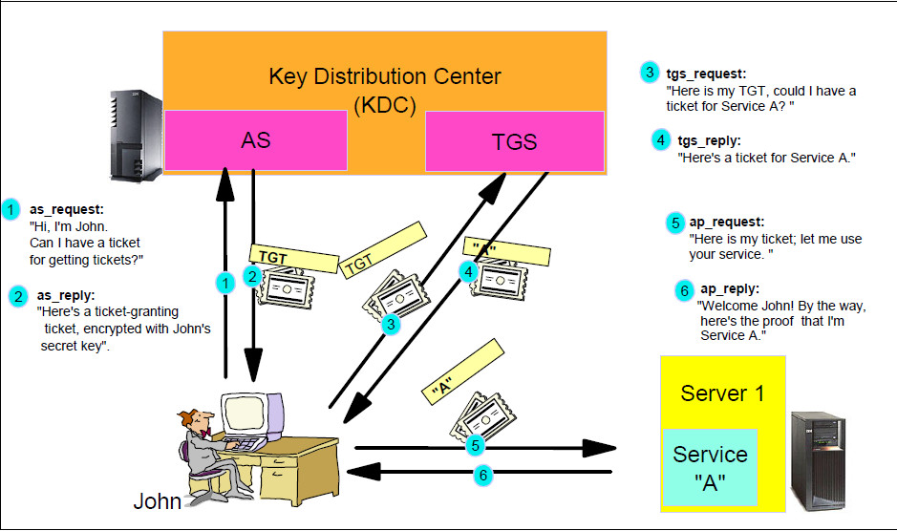

Identity proofing: The process of collecting and verifying information about a person for the purpose of proving that a person who has requested an account, a credential, or other special privilege is indeed who he or she claims to be, and establishing a reliable relations.

Identity as a Serive (IDaaS): Cloud-based service that broker identity and access management function to target systems on customer’s premises and/or in the cloud.

Facility access control: Protect enterprise assets and provide a history of who gained access and when the access was granted.

Electronic authentication (e-authentication) : The process of establishing confidence in user identities electronically presented to an information system.

Cryptographic Device: A hardware device that contains non-programmable logic and non-volatile storage dedicated to all cryptographic operations and protection of private keys.

Authorization: The process of defining the specific resources a user needs and determining the type of access to those resources the user may have.

Remote Authentication Dial-in User Service (RADIUS): An authentication protocol used mainly in networked environments, such as ISPs, or for similar service requiring single sign-on for layer 3 network access, for scalable authentication combined with an acceptable degree of security.

**Network Isolation:**

The key to virtual network security is isolation. Every host has a management network through which it communicates with other hosts and management systems. In a VIRTUAL INFRASTRUCTURE, THE MANAGEMENT NETWORK SHOULD BE ISOLATED PHYSICALLY and VIRTUALLY.

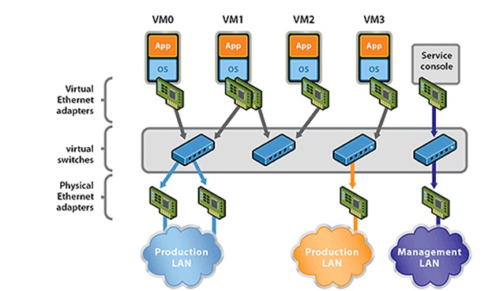

**VLANs**

The virtual machines network requires as much protection as the physical network. Using VLANs can improve networking security in your environment

* In simple terms, a VLAN is a set of workstations within a LAN that can communicate with each other as though they were on a single isolated LAN.
* When properly configured, VLANs provide a dependable means to protect a set of virtual machine from accidental or malicious instructions.

**VLAN Communication**

* Broadcast packets sent by one of the workstation will reach all the others in the same VLAN.
* Broadcast sent by one of the workstation in the VLAN will not reach any workstation that are not in the VLAN.
* Broadcasts sent by workstations that are not in the VLAN will never reach workstation that are in the VLAN.
* The workstation can communicate with each other without needing to go through a gateway.

VLAN Advantages

The ability to isolate network traffic to certain machines or groups of machines vis association with VLAN allows for the opportunity to create a secured pathing of data between endpoints..

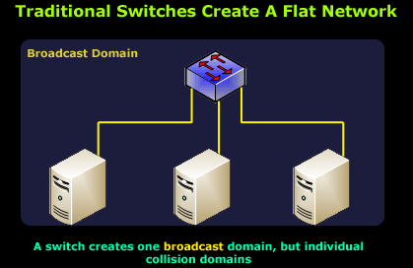

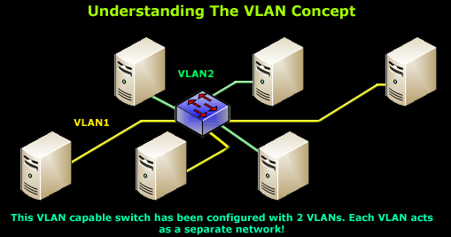

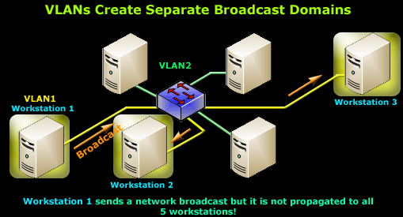

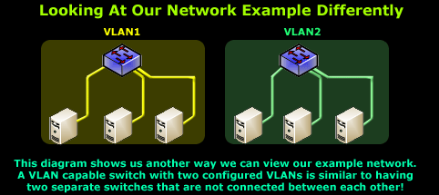

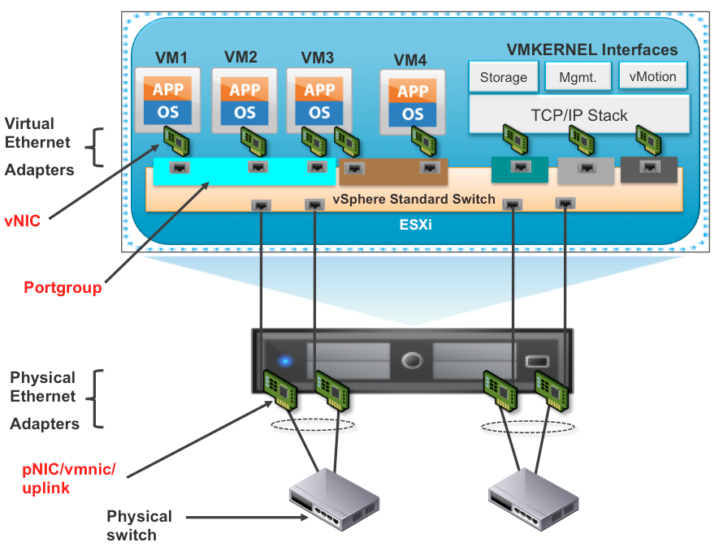

**Local Area Network (LAN)**

• **Covering a limited geographical area**

• **Ethernet and Token Ring**

**Metropolitan Area Network (MAN)**

• **Network that extends over a city or town**

• **SONET rings, FDDI**

**Wide Area Network (WAN)**

• **Covering a wide geographical area**

• **ATM, Frame Relay, X.25**

**Wireless technologies - WEP**

**Wired Equivalent Privacy**

• Protocol used to encrypt traffic for all IEEE wireless standards

• Protects device-to-device or device-to-AP traffic

• The standard is riddled with security flaws

• Most insecurities come from improper implementation of the security mechanisms

**Same symmetric key implementation**

• No randomness added

• Similar to using the same password

• Increases window of opportunity to be cracked

**No automated dynamic key refresh method**

• Today, we have many key agreement and exchange protocols and

algorithms

• Reason for asymmetric algorithm invention

• Diffie-Hellman, RSA, etc.

• IKE

• Requires manual key refres

**Wireless technologies – Common attacks**

**Attacks on WLANs**

• Eavesdropping on traffic and spoofing

• Erecting a rogue AP

• Wireless devices will then authenticate to a bogus AP

• Attacker obtains access credentials

• Man-in-the-middle

• All traffic going through the attacker’s system without users knowing it

• Unauthorized modification of data

• Gaining access to the wired network

• War driving

• Cracking WEP

• Collision attacks – Birthday attacks

• Weak key attacks – Key discovery and brute-forcing 40-bit key

• AirSnort, WEPCrack

Protocols

TCP and UDP

ICMP

ARP

SNMP

SMTP

LPD

NFS

TFTP

FTP

Telnet

BootP

Address Resolution Protocol

• Maps the IP address to the media access control (MAC) address

• IP address = 32-bit software assigned

• Network layer

• MAC address = 48-bit hardwired into NIC

• Data link Layer

• Data link layer protocols understand MAC addresses, not IP addresses



Protocols – ICMP

Internet Control Message Protocol

• Status and error messaging protocol

• Not used to move user data

• Ping utility uses this protocol

• ICMP ECHO Request and Reply

ICMP uses by hackers

• Allowed through most firewalls

• Used for host enumeration

• Redirect traffic by sending bogus ICMP messages to router

• Router “thinks” that another router is telling it that a link is down or congested



**Networking devices**

**LAN, MAN and WAN devices**

• **Repeater**

• **Hub**

• **Bridge**

• **Switch**

• **Router**



Network devices – Switch

Switch characteristics

• Transfer a connection from one circuit to another circuit

• Faster than most bridges and routers because instructions are working at the silicon level

• Makes forwarding decisions based on MAC addresses

• Newer switches can perform some routing

• Major functionality takes place at the data link layer

• Many switches today work between the data link and transport layer



Network devices – Firewalls

Firewall characteristics

• Many types on the market today

• Different functionalities and protection levels

• Provides transparent protection to internal users

Firewall Types

• Generation 1 = Packet filtering

• Generation 2 = Proxy

• Generation 3 = Stateful

• Generation 4 = Dynamic packet filtering

• Generation 5 = Kernel proxies



**Types of firewalls – Dynamic packet-filtering**

**Dynamic packet-filtering characteristics**

• Combination of application proxies and stateful inspection Firewalls

• Dynamically changes filtering rules based on several different factors

• Reactive to pre-designed changes and situations

• Fourth-generation firewall

**Firewall architecture types – Multi- or dual-homed**

**Description**

• Two or more interfaces, one for each network

• Allows for one firewall to create more than one DMZ

• Forwarding and routing need to be turned off

• Otherwise, packets would not be inspected by firewall software



Dial-up protocols and authentication protocols

Dial-up protocols

• PPP

• SLIP

Authentication

Protocols

• Password Authentication Protocol (PAP)

• Challenge Handshake Authentication Protocol (CHAP)

• Extensible Authentication Protocol (EAP)



Authentication protocol – EAP

Extensible Authentication Protocol

• Allows for modular authentication protocols to be “plugged in” to give companies more flexibility

• Provides a framework for several different authentication methods to be used

• Passwords, challenge-response, PKI, Kerberos and more

• Developed for PPP connections, but is now used in LAN and wireless authentication technologies

• In LAN authentication, it is usually used with 802.1x (port authentication technology)

Virtual Private Network technologies

Tunneling protocols

• Point-to-Point Tunneling Protocol (PPTP)

• Layer 2 Tunneling Protocol (L2TP)

• IPSec

MAN technologies – SONET

Synchronous Optical

Network

• Physical layer standard used by telecommunication companies

• Defines transmission rates, signal formats and optical interfaces

• Dual-ringed and self-healing if a line should go down

• Optical carrier rings are used to connect T1s and T3s and other communication channels together

• Think of it as the highway that cars can run over

• The cars can be frame relay, ATM, X.25

and many other types of frames

• Voice, data and video can be moved over SONET rings



**Wide Area Network technologies**

WAN technologies

• Dedicated lines

• ISDN

• DSL

• Frame relay

• X.25

• SMDS

• ATM

• VoI**P**

**WAN technologies are circuit or packet switched**

**Circuit switching**

• **A virtual connection is set up and used throughout the whole communication session**

• **Traffic travels in a predictable and constant manner**

• **Fixed delays**

• **Usually carries voice-oriented data**

• **Telephone calls**

**Packet switching**

• **Packets can be sent through different paths to reach the same destination**

• **No virtual connection is set up**

• **Supports traffic that is bursty**

• **Variable delays**

• **Usually carries data-oriented information**

• **X.25, frame relay, SMDS**

**Voice Over IP**

**VoIP characteristics**

Moving voice data in packets

Companies are combining their data networks and voice networks into one network

Popular because of the cost savings in maintenance

Long distance calls can be done cheaply

Voice data is not traveling over the telephone company’s lines

Currently this is not FCC-regulated

Regular telephone calls use a circuit-switched technology, but VoIP uses a packet-switched technology

Can experience jittering and latency



**Cryptography objectives**

* **Historical uses of cryptography**
* **Foundational pieces of cryptography**
* **Symmetric and Asymmetric Algorithms**
* **Public Key Infrastructure**
* **E-mail client encryption procedures**
* **Protocols that use cryptography**
* **Attacks on cryptography**

Cryptography uses yesterday and today

In the past

* Cryptography was mainly used for providing confidentiality
* It protected sensitive information, mainly during transmission

Today

• Still used for confidentiality

• Also used for:

• Data integrity

• Source authentication

• Non-repudiation

Key and algorithm relationship

Key

• Long string of random values

Algorithm

• Group of mathematical equations that can be used for the encryption and decryption processes

Used together

• Key values are used by the algorithms to indicate which equations to use, in what order and with what values

**Why does a 128-bit key provide more protection than a 64-bit key?**

**Keyspace**

• **All possible values that can be used to generate a key**

• **The larger the key size, the larger the keyspace**

• **264 < 2128**

• **The larger the keyspace, the more values an attacker has to brute force**



Strength of a cryptosystem

Determining strength in cryptography

• Strength of a cryptosystem depends upon

• Proper development of the algorithm

• Secrecy and protection of key

• Length of the key

• Initialization vectors

• How all of these pieces are implemented and work together

• **Today the most successful attacks are against the human factor of cryptography**

• Improper implementation and key management

Types of ciphers used today

Modern cryptography

• Substitution methods

• Transposition methods

• Symmetric ciphers

• Block ciphers

• Stream ciphers

• Asymmetric ciphers

**Symmetric key cryptography**

**Characteristics**

• Sender and receiver **use the same key** to encrypt and decrypt a message

• Protection depends upon users keeping the symmetric key secret

• Requires “**out-of-band**” exchange of keys

• Secure courier or sneaker net

• **Can provide confidentiality, but not true authenticity or nonrepudiation**

• Does not scale well in large environments

• Works well and is hard to break if a large key size is used

• Cannot be easily used for network or wireless authentication

Symmetric algorithm examples

Symmetric algorithms

* Data encryption standard (DES)
* 3DES
* Blowfish
* Twofish
* IDEA
  + International data encryption algorithm
* RC4, RC5, RC6
* AES



**Asymmetric cryptography**

**Asymmetric key systems characteristics**

• Also called public key cryptography

• Two different keys are used = public and private keys

• Public key can be given to anyone

• **Private key is possessed by only one owner**

• **The public and private keys are mathematically related, but should not be able to be derived from each other**

• Keys have dual natures

• Can encrypt and decrypt

• Data encrypted with public key can only be decrypted by corresponding private key

• Data encrypted with private key can only be decrypted by corresponding public key

**Asymmetric algorithm examples**

**Asymmetric algorithms**

• **RSA**

• **Elliptic Curve Cryptosystem (ECC)**

• **Diffie-Hellman**

• **El Gamal**

• **Knapsack**

First asymmetric algorithm

Diffie-Hellman

• A key agreement protocol

• Agreement on the symmetric session key that will be used for encryption

purposes

• This does not require a previous relationship between the two parties needing to communicate

• Allows key agreement to happen in a secure manner

• Security based on calculating discrete logarithms in a finite field

• **Vulnerable to man-in-the-middle attacks – lack of authentication**

• Does not provide data encryption or digital signature capabilities

Asymmetric algorithm – RSA

RSA•

Developed by Ron Rivest, Adi Shamir and Leonard Adleman

• Provides digital signature, key distribution and encryption services

• Mathematics = Difficulty of factoring large numbers

• Uses a one-way function = mathematically easy to carry out in one direction, but basically impossible to carry out in reverse

• Easy direction = multiplying prime numbers

• Hard direction = factoring large number into its original prime numbers

• Decryption key “knows a secret” to carry out the hard direction easily

• Sometimes called a trapdoor

Evolution of DES

Triple DES

• In the 1990s, a “DES Cracker” machine was built that could recover a DES key in a few hours

• DES was broken and we needed a solution before AES was created and implemented

• Performance hit because of extra processing

• Provides more protection by providing 3 rounds of encryption

• This can take place with two or three different keys, depending on the mode

• DES-EEE3 uses three keys for encryption

• DES-EDE3 uses 3 different keys, encrypts, decrypts and encrypts data

• DES-EEE2 and DES-EDE2 are the same as the previous mode, but the first and third operations use the same key



**Symmetric cipher - AES**

**Advanced Encryption Standard**

• **Replacement for DES**

• **Block symmetric encryption algorithm**

• **U.S. official standard for sensitive but unclassified data encryption**

• **Rijndael algorithm**

• **Key sizes of 128, 192, 256**



Data integrity mechanisms

Hashing algorithms:

• MD2 (128-bit digest)

• MD4 (128-bit digest)

• MD5 (128-bit digest)

• SHA-1 (160-bit digest) (NIST)

• SHA-256 (256-bit digest) (NIST)

• SHA-512 (512-bit digest) (NIST)

• HAVAL (Variable length message digests)



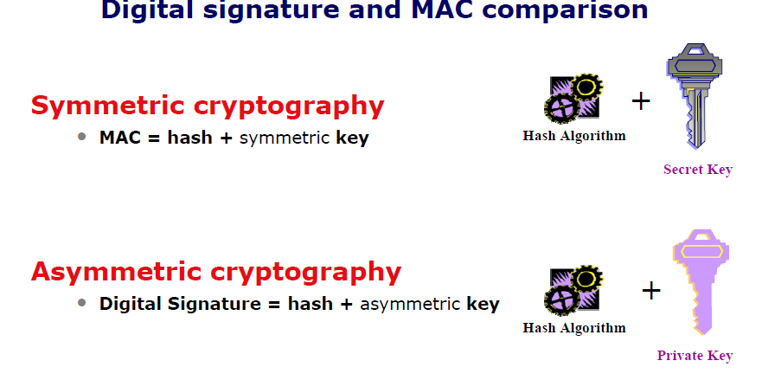

PKI and its components

Components in a Public Key Infrastructure

• CA

• RA

• Certificate repository

• Certificate revocation system

Digital certificates

Characteristics

• Currently using X.509 version 3

• Associates public key with owner

• Digitally signed by CA



Secure protocols

Secure Hypertext Transport Protocol (S-HTTP)

• Protects each message – not communication channel

• Older, less-used technology

HTTPS

• HTTP runs on top of SSL

• Provides a secure communication channel

• All messages and other data is protected

Secure Sockets Layer (SSL)

• Originally developed by Netscape

• Requires a PKI to use

• Server authenticates to client, optionally client can authenticate to server

• Client creates session key and sends to server

• Works at transport layer

**Link versus end-to-end encryption**

**Link encryption**

• Full frames are encryption – payload, headers and trailers

• Telephone circuit, T1, satellite link

• Usually provided by service providers over point-to-point connections

• Usually uses dedicated link encryption devices

• Each hop has to decrypt headers – if a hop is compromised, all traffic going through that hop can be compromised

• Data link messaging is not encrypted

• Control information used by dedicated link encryption devices



**Network layer protection**

**IPsec**

• **Developed because IPv4 has no security mechanisms**

• **Integrated in IPv6**

• **Sets up a secure channel between computers instead of applications**

• **Application secure channels are usually provided with SSL**

• **Network layer security**

• **Can provide host-to-host, host-to-subnet, and subnet-to-subnet connections**

**IPsec key management**

**Manual**

• **Each device is configured with a symmetric key and security association nformation**

**Internet Key Exchange (IKE) is the de facto standard**

• **Hybrid of Internet Security Association and Key Management Protocol (ISAKMP) and Oakley Key Exchange**

• **Phase 1 = Establishing the session key to provide a secure channel for handshaking to take place securely**

• **Phase 2 = SAs are negotiated for keying material and parameter negotiation**



DES Modes

CBK‐4: Cryptography

Modes of DES (4‐5 types)

• Block Modes

– Electronic Code Book (ECB): weakest/fastest

– Cipher Block Chaining (CBC): most frequently used

• Stream Modes

– Cipher Feed Back (CFB)

– Output Feed Back (OFB)

– Counter (CTR): may or may not be considered

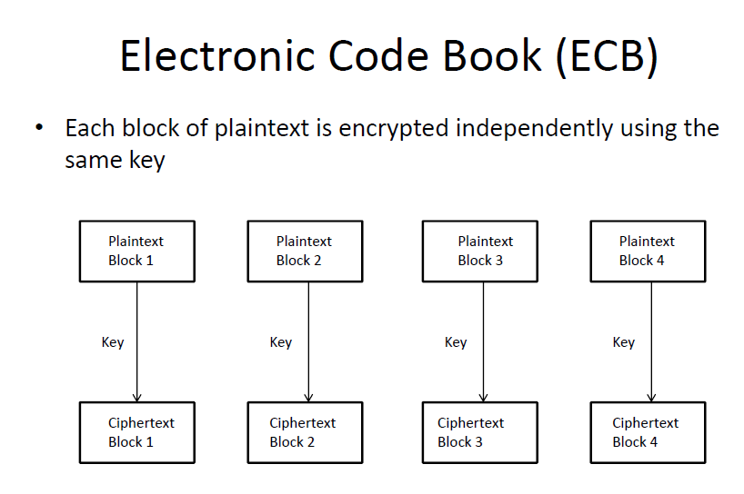

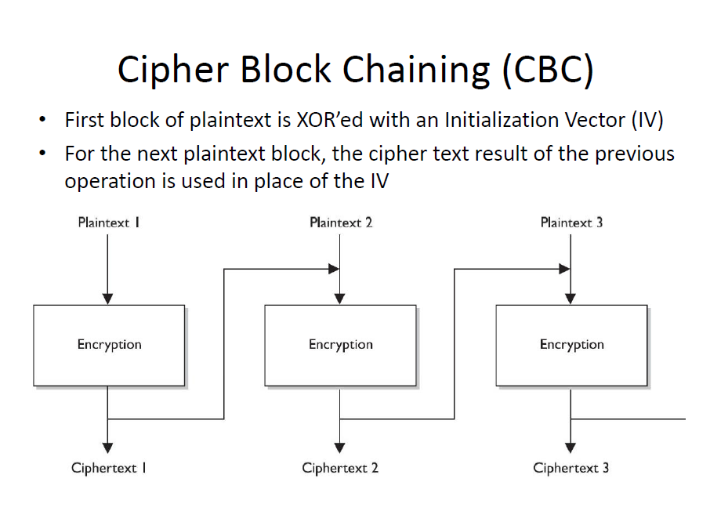

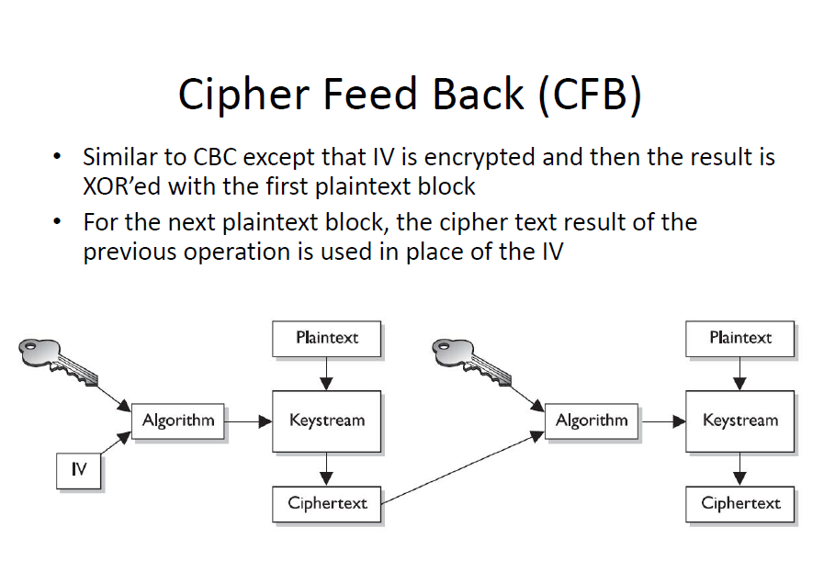

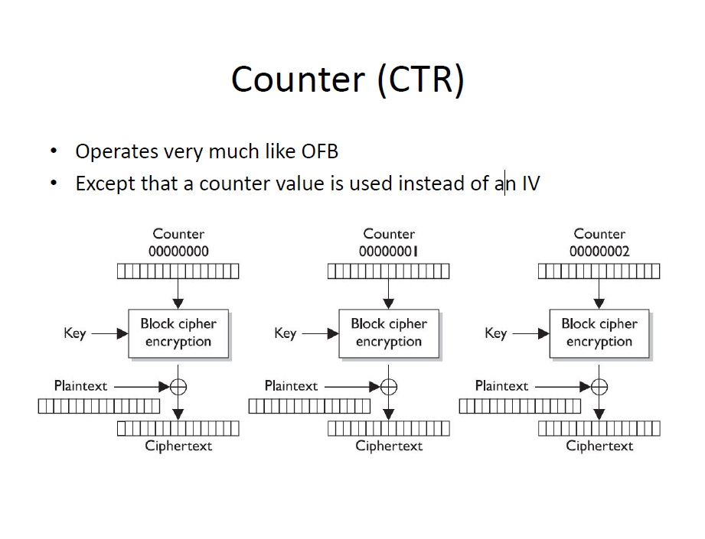

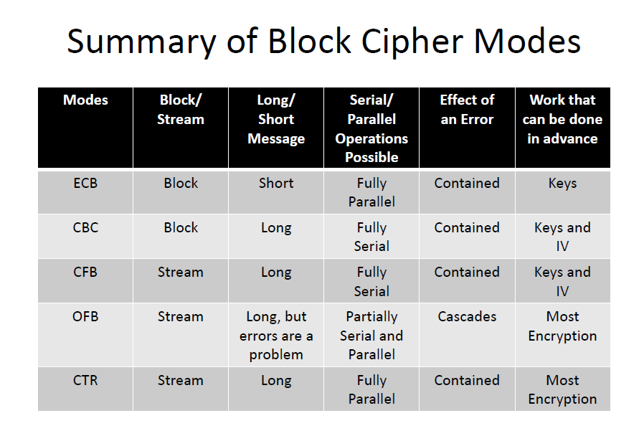

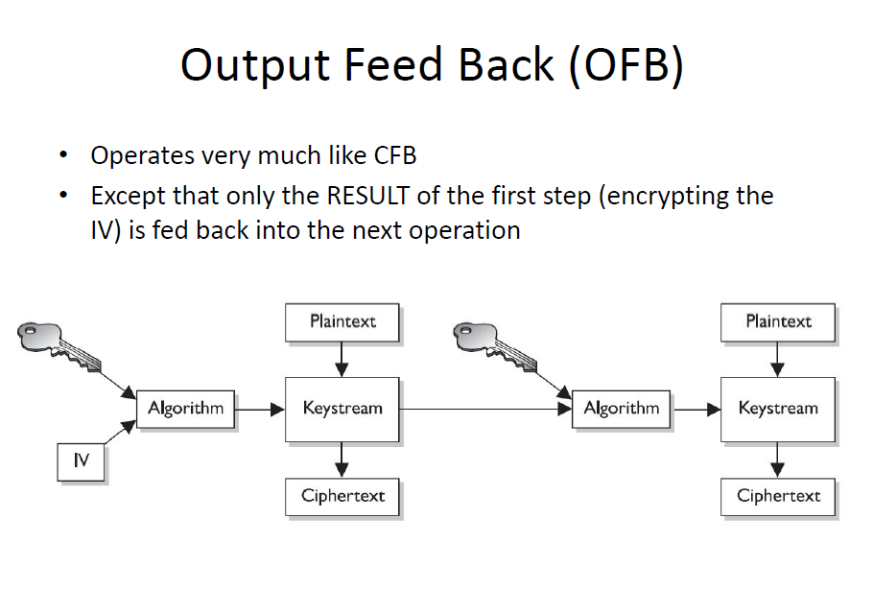

Ports -An IP address identifies a host machine on the Internet. -An IP port will identify a specific application running on an Internet host machine. -A port is identified by a number, the port number. -The number of ports is not functionally limited, in contrast to serial communications where only 4 ports are allowed. -There are some port numbers which are dedicated for specific applications.

Finger 79

Telnet 23

POP3 (e-mail) 110

SMTP (e-mail) 25

Gopher 70

FTP 20 and 21

Types of Networks There are two principle kinds of networks: Wide Area Networks (WANs) and Local Area Networks (LANs).

WANs -Cover cities, countries, and continents. -Based on packet switching technology -Examples of WAN technology: Asynchronous Transfer Mode (ATM), Integrated Services Digital Network (ISDN)

LANs -Cover buildings or a set of closely related buildings.

-Examples of LAN technology: Ethernet, Token Ring, and Fibber Distributed Data Interconnect (FDDI). Ethernet LANs: based on a bus topology and broadcast communication

Token ring LANs: based on ring topology FDDI LANs: use optical fibbers and an improved token ring mechanism based on two rings flowing in opposite directions.

